Marriage and Family Counseling Training Course
Return registration form and payment to:
GRACE REFORMED PRESBYTERIAN CHURCH
Attn.: Terri Smith
1111 Myers Street
Greeneville, TN 37743

DEADLINE: Sunday, December 7th, 2026

This course is offered by Grace Reformed Presbyterian Church as an extension of their Counseling Ministry. This course will be taught by ACBC* certified counselors Pastor Carel van der Merwe and Elder Neil Smith. Carel has served as pastor of GRPC for 30 years and is Director of the counseling ministry at GRPC. Neil has been serving as an elder at GRPC for 15 years and active in the counseling ministry as a counselor and instructor.
*ACBC (Association of Certified Biblical Counselors, formerly NANC – National Association of Nouthetic Counselors)



I myself am satisfied about you, my brothers, that you yourselves are full of goodness, filled with all knowledge and able to instruct one another.

Romans 15:14 (ESV)
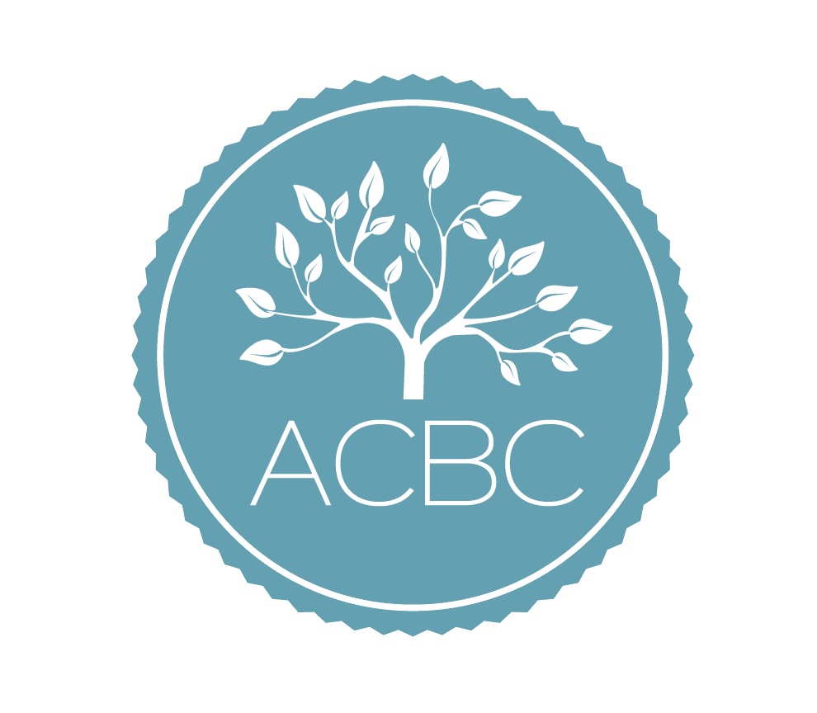
GRACE REFORMED PRESBYTERIAN CHURCH
1111 Myers Street
Greeneville, TN 37743

Class will meet in the fellowship hall
from 7 pm – 9 pm.

www.gracereformedpc.org

For more information:
Terri Smith – tmacne@aol.com

Pastor Carl van der Merwe
Cvdm1964@gmail.com

Marriage and Family Counseling
Training Course



GRACE REFORMED PRESBYTERIAN CHURCH Counseling Ministry

January 13th –
April 28th, 2026

Tuesdays
7pm-9pm



This 15 week - 30-hour course will equip counselors to offer biblical solutions to marriage and family problems. Topics will include Husband and Wife Relationships, Parent and Child Relationships, and Pre-Marriage counseling. Fundamentals of Biblical Counseling is strongly recommended before taking this course. (Orientation is required for students who have not taken Fundamentals course and will be held on Tuesday, January 6th from 7 pm-9pm).

Second year students will begin on Tuesday, 1/13/26.

This course is for men and women who desire to learn more about biblical counseling and the practical application of God’s Word to our lives as we grow in our sanctification.

This course will benefit those who desire certification with ACBC. This course combined with Introduction to Nouthetic Counseling Fundamentals course exceeds the Phase I requirement for the ACBC certification process.

All Scripture is given by inspiration of God, and is profitable for doctrine, for reproof, for correction, for instruction in righteousness, ¹⁷ that the man of God may be complete, thoroughly equipped for every good work.
2 Timothy 3:16-17 (NKJV)

CLASS SCHEDULE:



January 6th (Orientation if applicable)
January 13th – Week 1
January 20th
January 27th
February 3rd
February 10th
February 17th
February 24th
March 3rd
Spring Break
March 17th
March 24th
March 31st
April 7th
April 14th
April 21st
April 28th

Required textbooks, workbooks,
notes, pamphlets, etc. are included in registration fee and will be provided.

REGISTRATION FORM
Due by Sunday, December 7, 2025
NAME:

______________________________________

ADDRESS:

PHONE:
___________________________________
EMAIL:
___________________________________
Church where you attend:

___________________________________

ARE YOU INTERESTED IN ACBC CERTIFICATION?
YES_________MAYBE_________NO_____

Reason for taking course:

____________________________________________________________________________

TUITION: $175.00
(INCLUDES all Textbooks, notes and materials)


Complete registration form and include payment. Please make checks payable to:
Grace Reformed Presbyterian Church
Return to Terri Smith by Sunday, December 7th, 2025

